**CHAPTER 1**

**INTRODUCTION**

The main motive behind the project Rural Employment is to enhance one’s business or to help one’s start-up altogether it is kind helpful to Rural workers. It is basically two interface platform other than the admin panel one interface is for rural employers and other interface is for company or start-up. The platform behaves as an intermediary between the two. We know to start a new business or to enhance a business people hit into many needs.

For example, if one is contractor and he get a contract to build a university then he will be going to hit into needs - regular supply of cement, bricks, furniture etc or if one is going to start a start-up of coffee house he hit into needs of regular supply of coffee, kulhad etc and we know these things are mainly famous in rural areas so we came up with the idea to make these things easy and better. The platform creates a link between supplier and company and provides a way for their interaction.

**CHAPTER 2**

**SYSTEM ANALYSIS**

* EXISTING SYSTEM:

There exists project of rural employment but there is only focus is on rural people employment under somebody business/corporate but not to enhance their business at their own pace. People get employment under some scheme to make them work under some community. There are also different schemes for women employment.

* PROPOSED SYSTEM:

The project Rural Employment is to enhance one’s business or to help one’s start-up altogether it is kind helpful to Rural workers. It is basically to interface platform other than the admin panel one interface is for rural employers and other interface is for company or start-up. The platform behaves as an intermediary between the two. We know to start a new business or to enhance a business people hit into many needs. if one is contractor and he get a contract to build a university then he will be going to hit into needs - regular supply of cement, bricks, furniture etc or if one is going to start a start-up of coffee house he hit into needs of regular supply of coffee, kulhad etc and we know these things are mainly famous in rural areas so we came up with the idea to make these things easy and better. The platform creates a link between supplier and company and provides a way for their interaction.

In the project they both rural suppliers and company create there profile by registration. Rural Employer can add there products in the profile which can be view by any company.

The company can request for any product he needs and the appropriate user , but the agreement is not done until the request is not accepted by the rural employers.

**CHAPTER 3**

**Feasibility Study**

Whenever we design a new system, normally the management will ask for a feasibility report of the new system. The management wants to know the technicalities and cost involved in creation of new system.

- Technical feasibility

- Economic feasibility

- Physical feasibility

* **Technical feasibility:**

Technical feasibility involves study to establish the technical capability of the system being created to accomplish all requirements to the user. The system should be capable of handling the proposed volume of data and provide users and operating environment to increase their efficiency.

For example, system should be capable of handling the proposed volume of data and provide users.

* **Economic feasibility:**

Economic feasibility involves study to establish the cost benefit analysis. Money spent on the system must be recorded in the form of benefit from the system. The benefits are of two types:

**Tangible benefits:**

* + Saving man labour to do tedious tasks saves time.

**Intangible benefits:**

* + Improves the quality of organization.

**CHAPTER 4**

**Software & Hardware requirements**

* Software Requirements:
* Technology: Python Django
* IDE: Visual studio
* Client-Side Technologies: HTML, CSS, Bootstrap
* Server-Side Technologies: Python
* Data Base Server: SQLite
* Operating System: Microsoft Windows/Linux
* Hardware Requirements:
* Processor: Pentium-III (or) Higher
* Ram: 64MB (or) Higher
* Hard disk: 80GB (or) Higher

**CHAPTER 5**

**System Design**

Design is the first step in the development phase for any techniques and principles for the purpose of defining a device, a process or system in sufficient detail to permit its physical realization.

Once the software requirements have been analysed and specified the software design involves three technical activities - design, coding, implementation and testing that are required to build and verify the software.

* **Unified Modelling Language Diagrams (UML):**
  + The unified modelling language allows the software engineer to express an analysis model using the modelling notation that is governed by a set of syntactic semantic and pragmatic rules.
  + A UML system is represented using five different views that describe the system from distinctly different perspective. Each view is defined by a set of diagram, which is as follows.
* **User Model View**

1. This view represents the system from the users perspective.
2. The analysis representation describes a usage scenario from the end-users perspective**.**

UML is specifically constructed through two different domains they are

* + UML Analysis modelling, which focuses on the user model and structural model views of the system?
  + UML design modelling, which focuses on the behavioural modelling, implementation modelling and environmental model views**.**

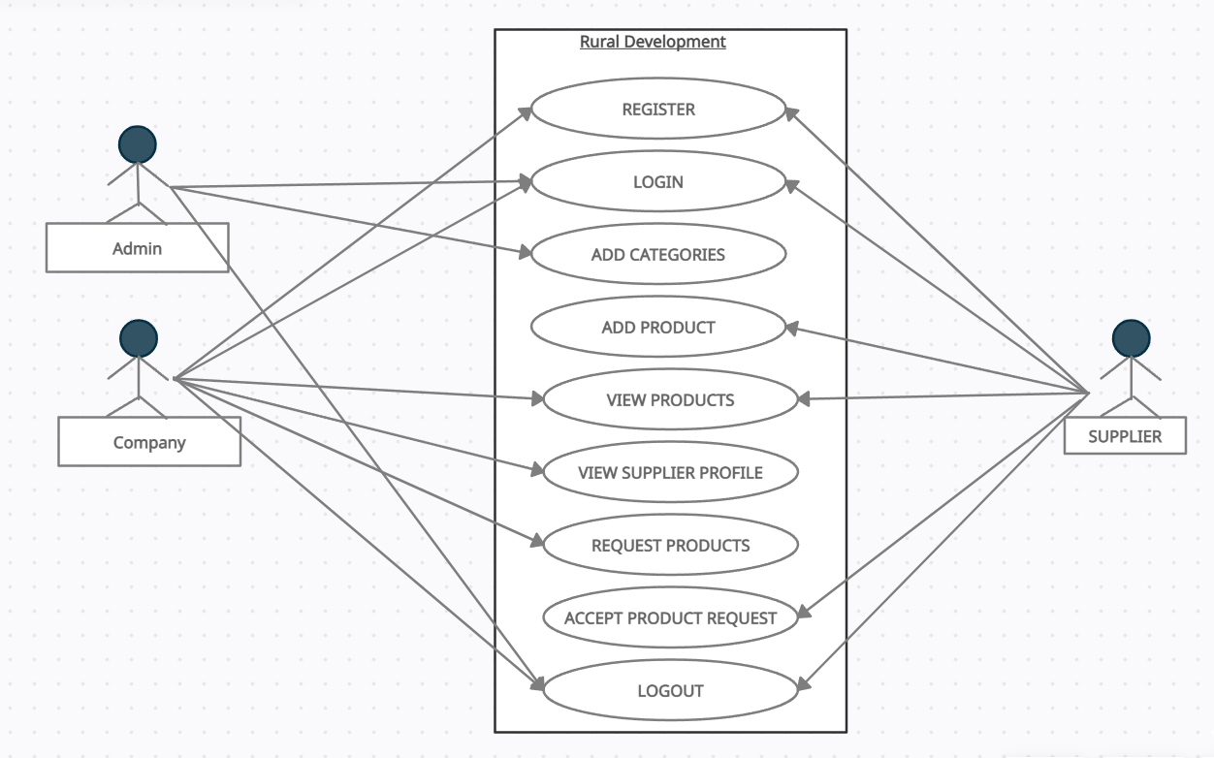

#### ENTITY-RELATIONSHIP DIAGRAM

E-R (Entity-Relationship) Diagram is used to represents the relationship between entities in the table.

## The symbols used in E-R diagrams are:

SYMBOL PURPOSE

Represents Entity sets.

Represent attributes.

Represent Relationship Sets.

Line represents flow

Structured analysis is a set of tools and techniques that the analyst.

To develop a new kind of a system:

The traditional approach focuses on the cost benefit and feasibility analysis, Project management, and hardware and software selection a personal consideration.

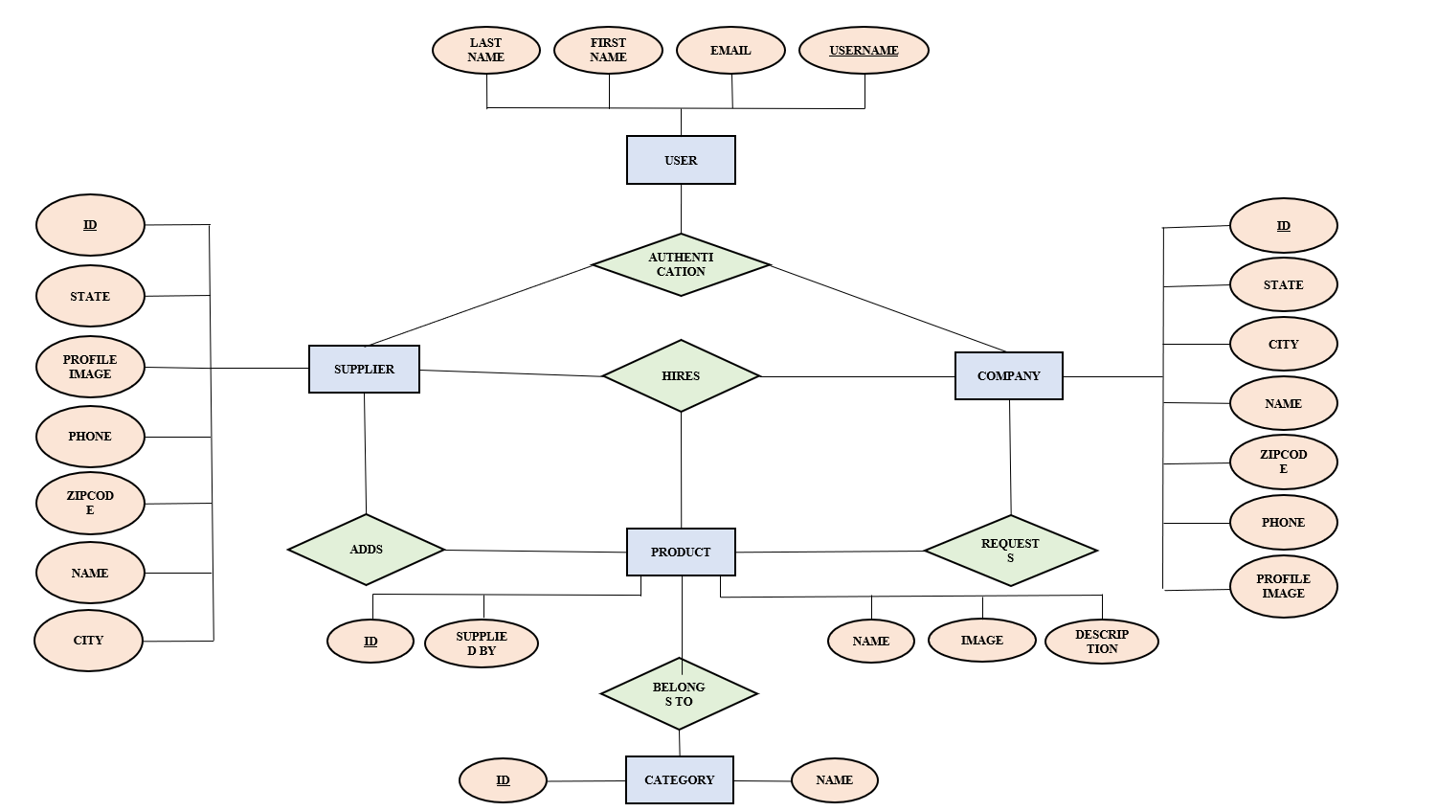

* DATA FLOW DIAGRAM

A data flow diagram (DFD) maps out the flow of information for any process or system. It uses defined symbols like rectangles, circles and arrows, plus short text labels, to show data inputs, outputs, storage points and the routes between each destination. Data flowcharts can range from simple, even hand-drawn process overviews, to in-depth, multi-level DFDs that dig progressively deeper into how the data is handled. They can be used to analyze an existing system or model a new one. Like all the best diagrams and charts, a DFD can often visually “say” things that would be hard to explain in words, and they work for both technical and nontechnical audiences, from developer to CEO. That’s why DFDs remain so popular after all these years. While they work well for data flow software and systems, they are less applicable nowadays to visualizing interactive, real-time or database-oriented software or systems.

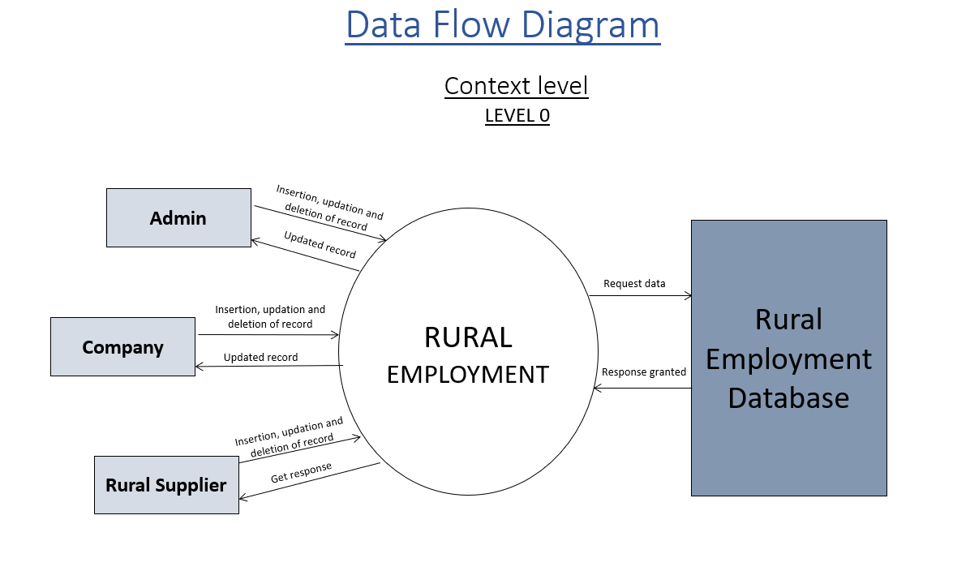

* **COMPANY LEVEL 1 DFD**

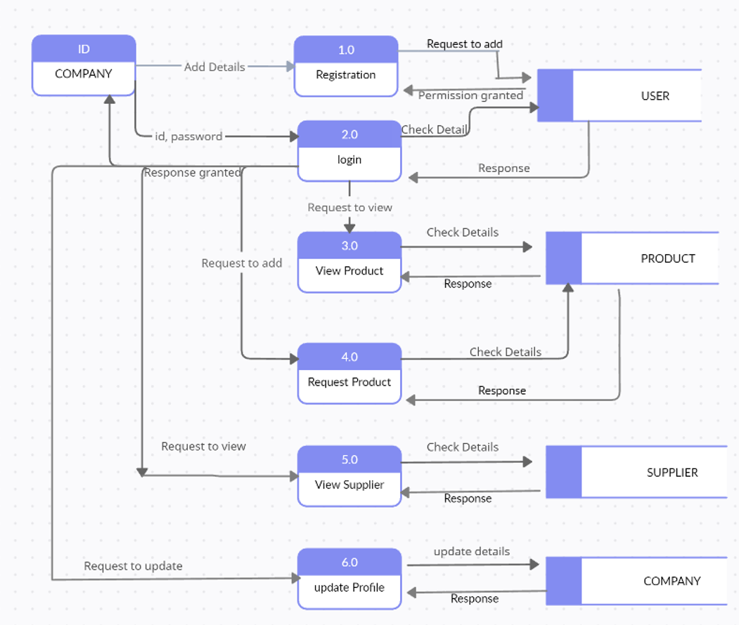

* **SUPPLIER LEVEL 1 DFD:**

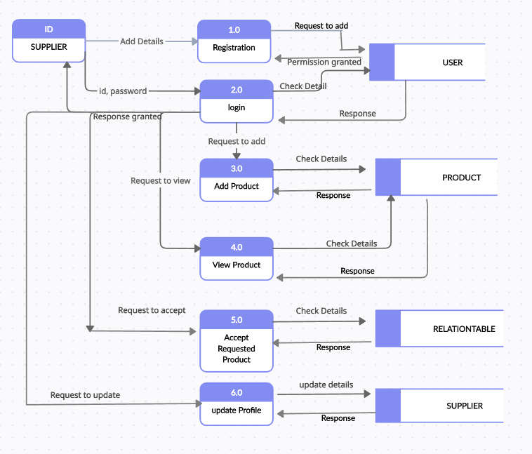

**CHAPTER 6**

**DATA DICTIONARY**

The data in the system has to be stored and retrieved from database. Designing the database is part of system design. Data elements and data structures to be stored have been identified at analysis stage. They are structured and put together to design the data storage and retrieval system.

A database is a collection of interrelated data stored with minimum redundancy to serve many users quickly and efficiently. The general objective is to make database access easy, quick, inexpensive and flexible for the user. Relationships are established between the data items and unnecessary data items are removed. Normalization is done to get an internal consistency of data and to have minimum redundancy and maximum stability. This ensures minimizing data storage required, minimizing chances of data inconsistencies and optimizing for updates. The MySQL database has been chosen for developing the relevant databases.

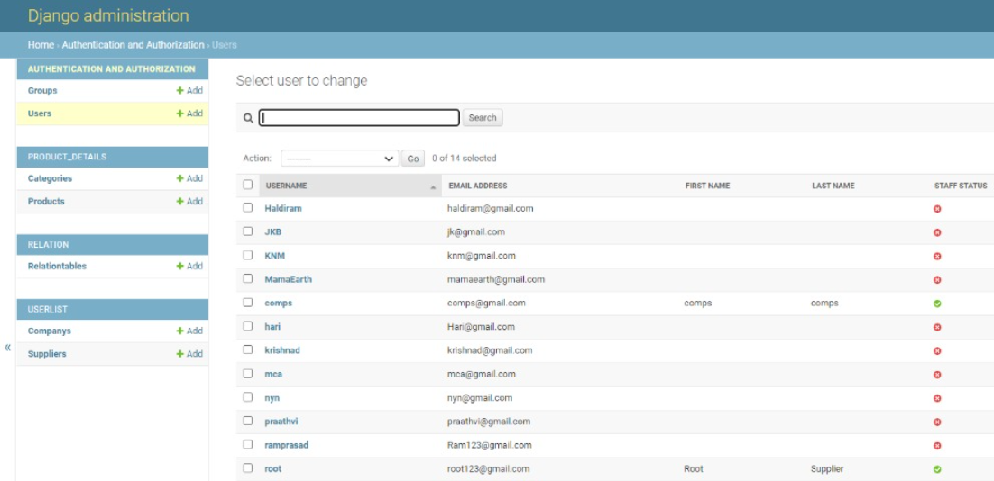

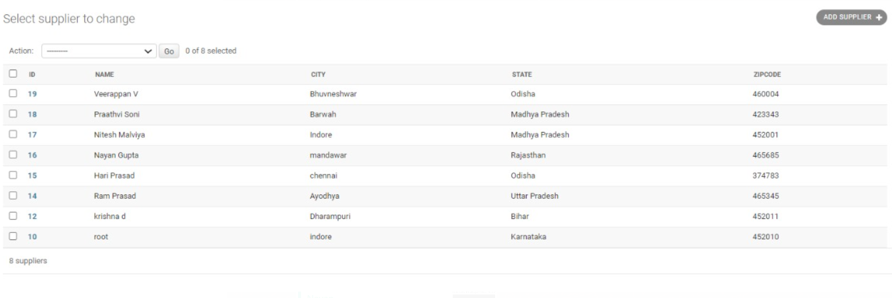

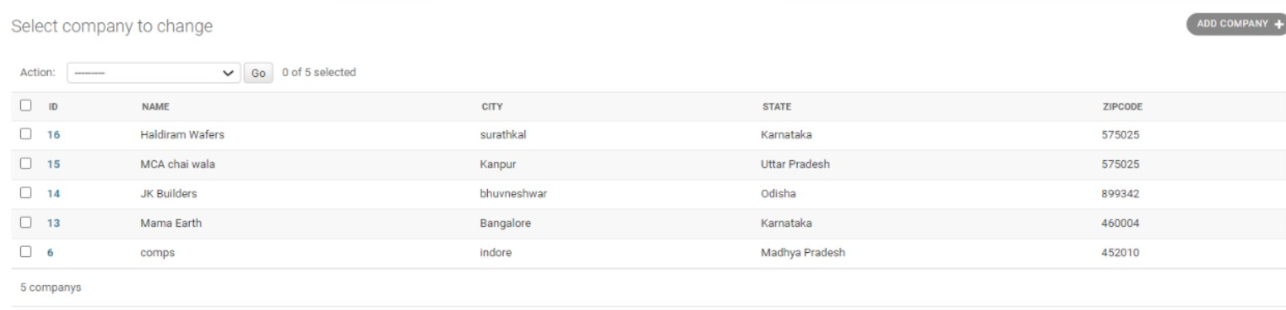

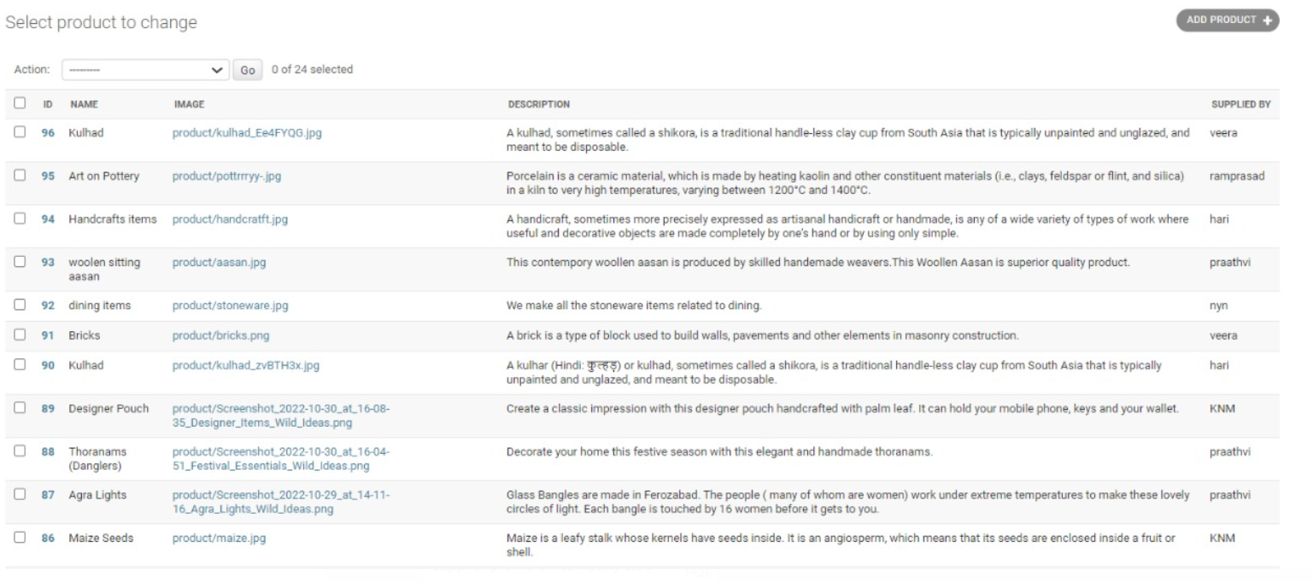

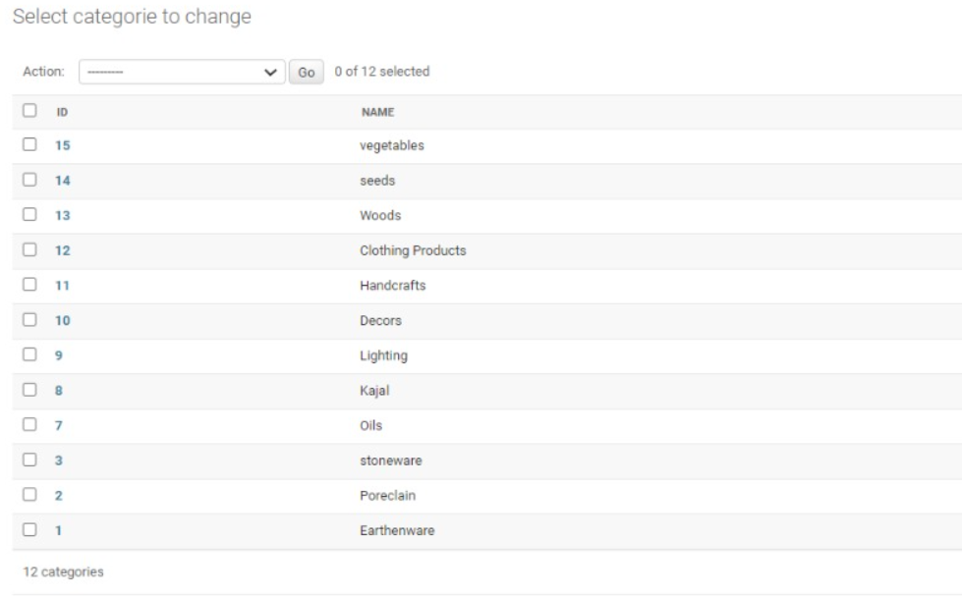

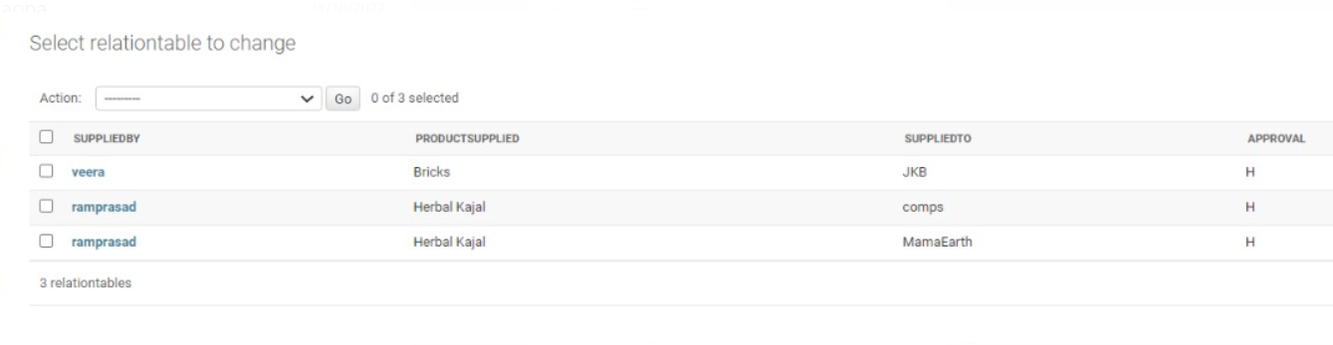

**CHAPTER** **7**

**Software Interface**

* **HOME PAGE:**

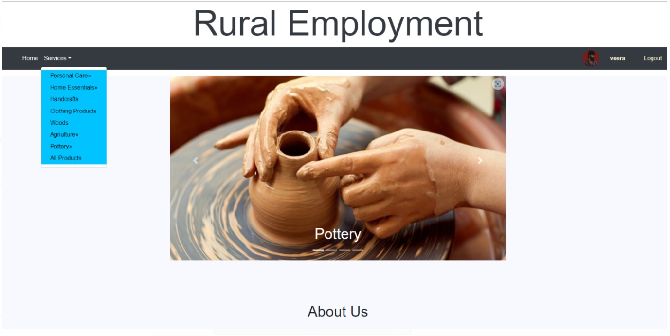

* **LOGIN PAGE:**

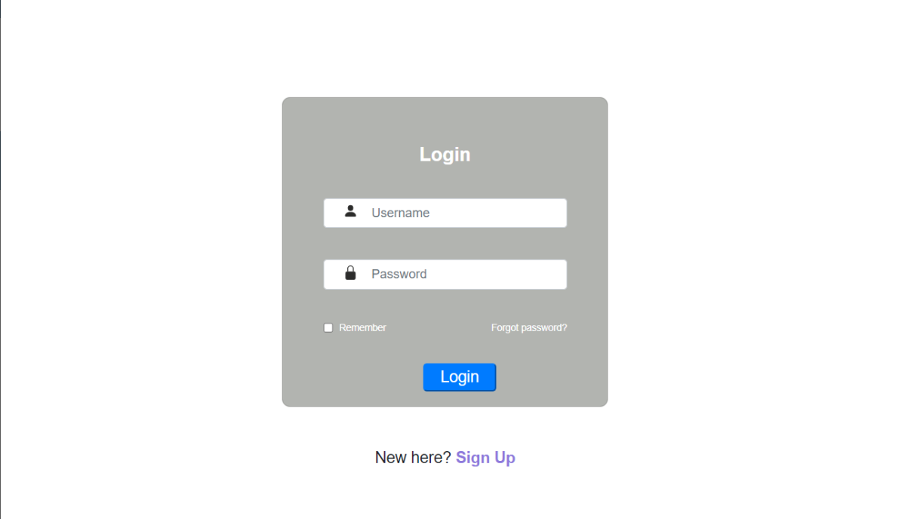

**REGISTRATION:**

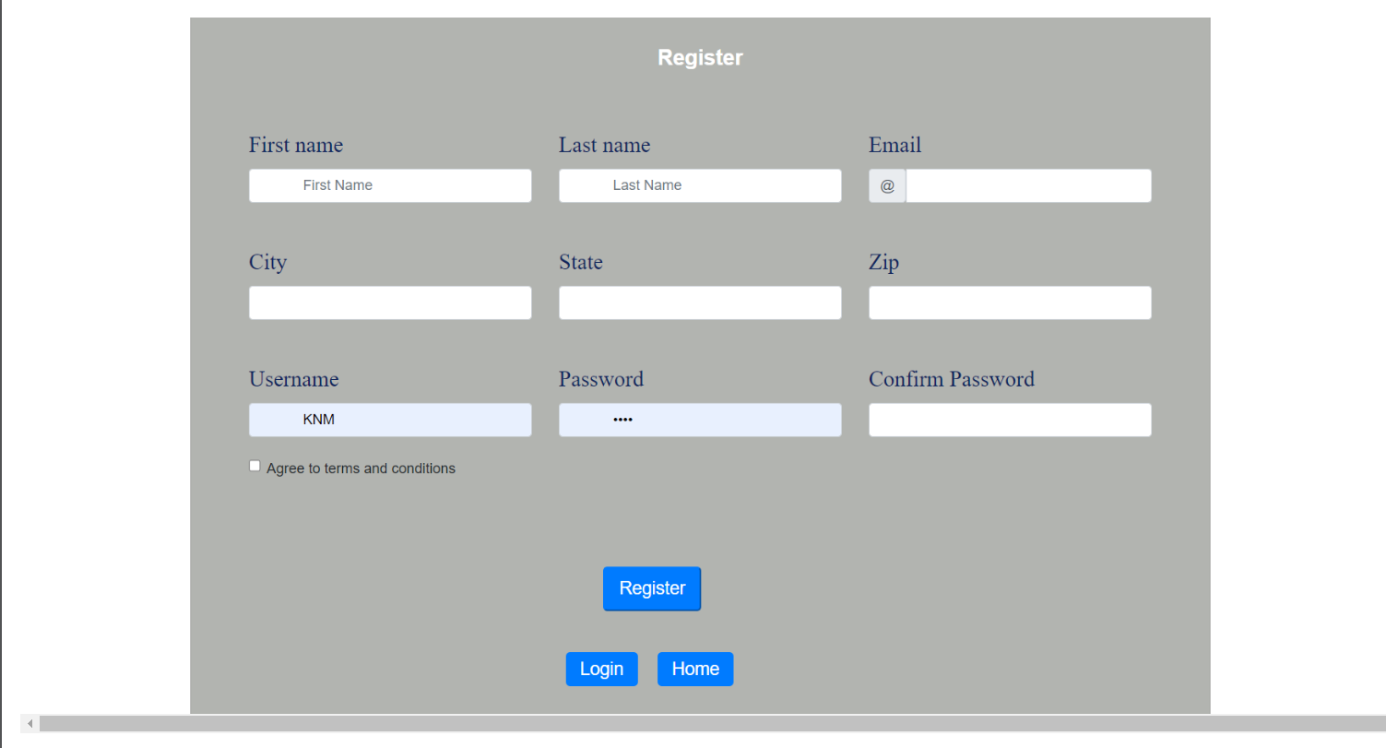

* **SUPPLIER PROFILE:**

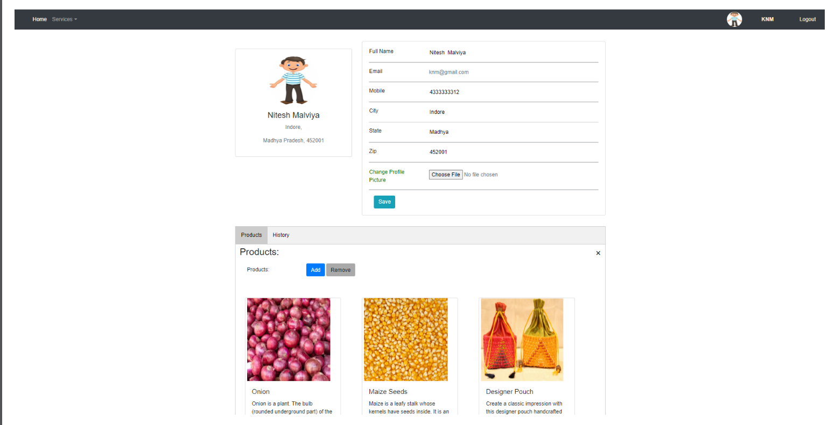

* **COMPANY PROFILE:**

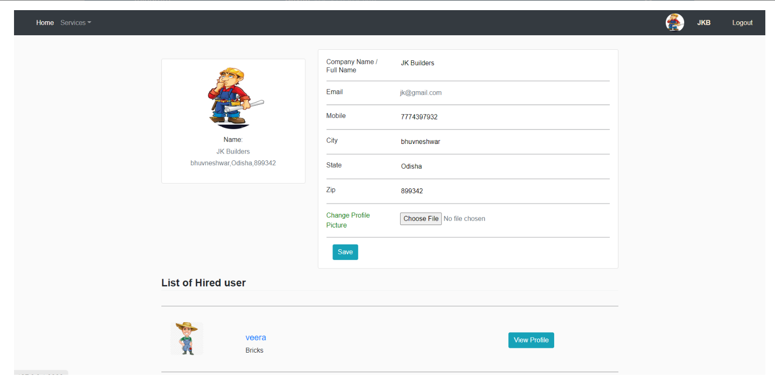

* **SUPPLIER PROFLE ON COMPANY SIDE:**

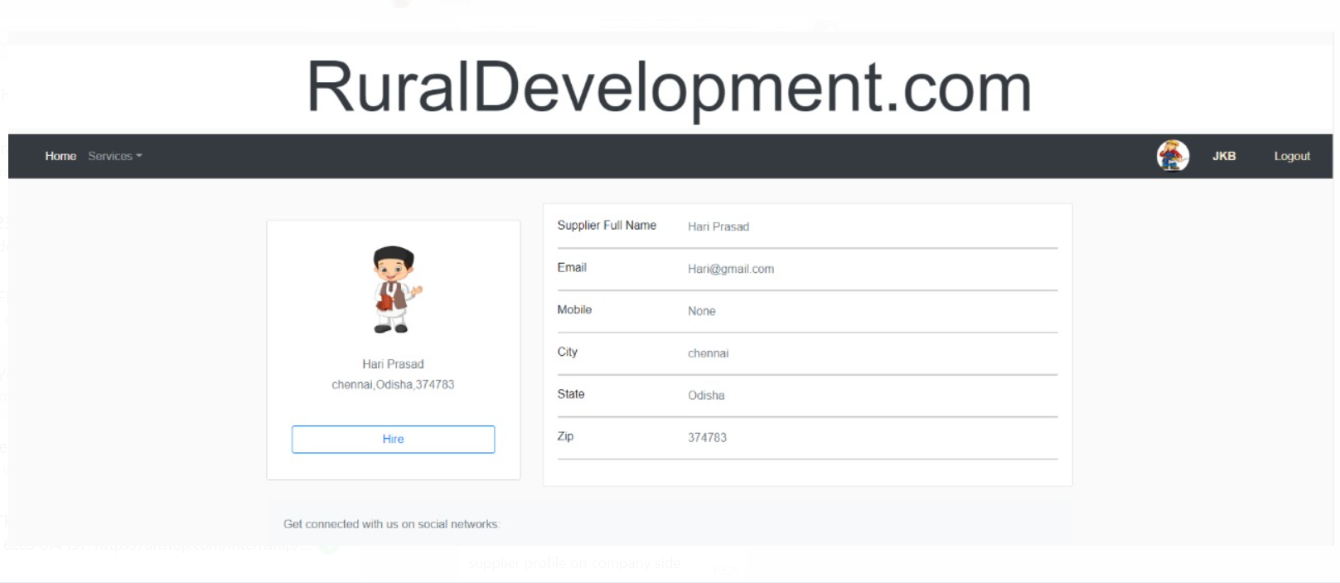

* **PRODUCT LIST:**

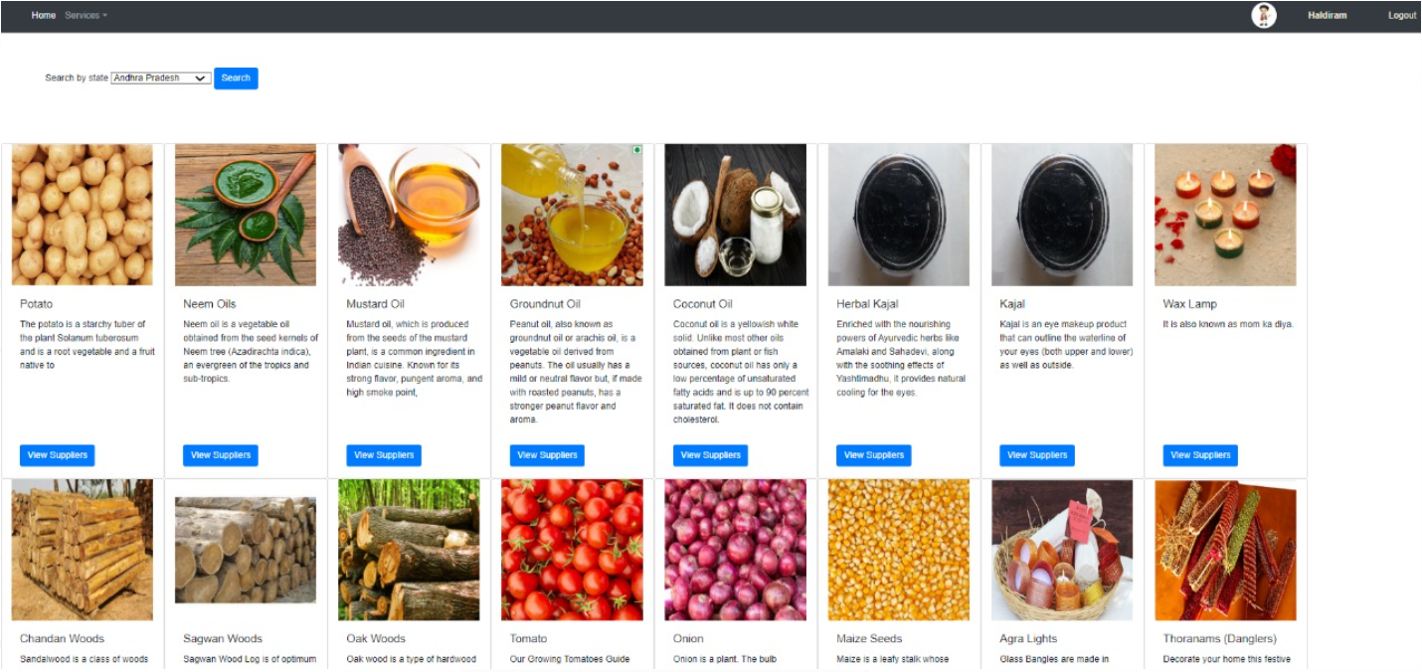

* **LIST OF SUPPLIERS:**

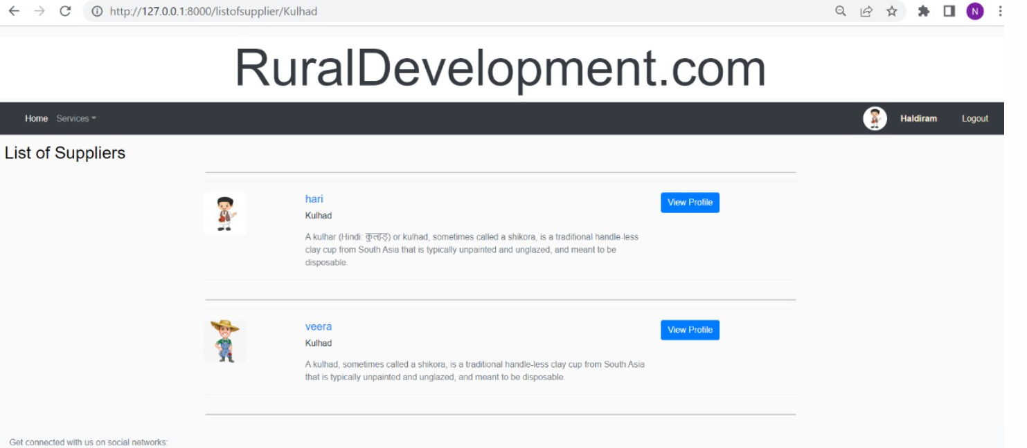

**CHAPTER** **7**

**Software Testing**

**CHAPTER 8**

**CONCLUSION**

The project Rural Employment is to enhance one’s business or to help one’s start-up altogether it is kind helpful to Rural workers. The platform behaves as an intermediary between the two. We know to start a new business or to enhance a business people hit into many needs.

For example, if one is contractor and he get a contract to build a university then he will be going to hit into needs - regular supply of cement, bricks, furniture etc or if one is going to start a start-up of coffee house he hit into needs of regular supply of coffee, kulhad etc and we know these things are mainly famous in rural areas so we came up with the idea to make these things easy and better. The platform creates a link between supplier and company and provides a way for their interaction.

**CHAPTER 9**

**BIBLIOGRAPHY**

* Wikipedia
* <https://www.geeksforgeeks.org/python-django/>
* <https://www.javatpoint.com>
* <https://www.python.org/>
* <https://www.tutorialspoint/>